**Pack 48 Pinewood Derby 2017**

**Corinthian Yacht Club**

Wednesday, February 15: Track Set – Up and Weigh In

Thursday, February 16: Race Night

**2017 Marin Council Pinewood Derby Rules**

* Cars must have been made for this year’s race.
* Width shall not exceed 2 ¾”.
* Length shall not exceed 7”.
* Width between wheels must be at least 1 ¾”.
* Cars must weigh no more than 5 ounces.
* Any weight can be used as long as it does not interfere with the clearance or the dimensions. Weights must be securely attached and stationary.
* Clearance between the track and underside of car should be no less than 3/8”.
* Only official BSA wheels and axles must be used (colored or black).
* Wheels may protrude beyond the front of rear of the car.
* No modification of the kit axle is allowed, except they may be polished and burrs sanded.
* The axle slots on the wooden block cannot be moved or altered.
* No paint or clear coat is allowed on kit wheels.
* No hubcaps.
* Only dry lubricant (Teflon, graphite) may be used on wheels.
* The nose of the car must be at least ½” wide I order to rest on starting peg.
* The running surface must remain flat.
* All four wheels must be in contact with the track at all times.

**The following information must appear clearly on the bottom of the car:**

Name

Pack #

Best contact number

Email

Use Science to Make your Pinewood Derby Car Go Faster

1. 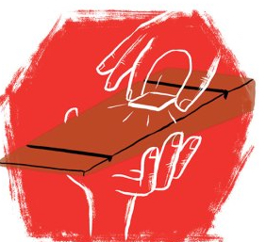Your **pinewood derby car MUST WEIGH-IN at, or less than, 5 OUNCES.** Make sure the heaviest part is about 1 inch in front of the rear axle. This is the most important step. Science shows if you do this correctly, you will beat a pinewood derby car built exactly the same — except with the weight toward its front — by 4.6 car lengths. It works because the farther back the weight is, the more potential energy you have because your center of mass is higher up on the track. (Don’t put it too far back, or your pinewood derby car will become unstable and pop a wheelie.)

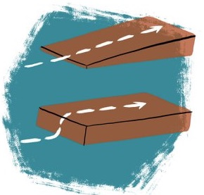

1. **Create a pinewood derby car that is reasonably aerodynamic,** meaning its design cuts down on drag caused by air. No need to get crazy here, but simply having a wedge-shaped pinewood derby car instead of the standard block out of the box will equal a 1.4-car advantage at the finish line.

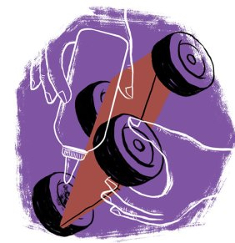

1. **Use lots of graphite.** There isn’t a big difference in types of graphite, so buy the cheap stuff and use as much as possible. Be sure to get plenty around each wheel and on the axle.